2015 Landmark Awards Category: Multifamily
Finalist: The Sovereign
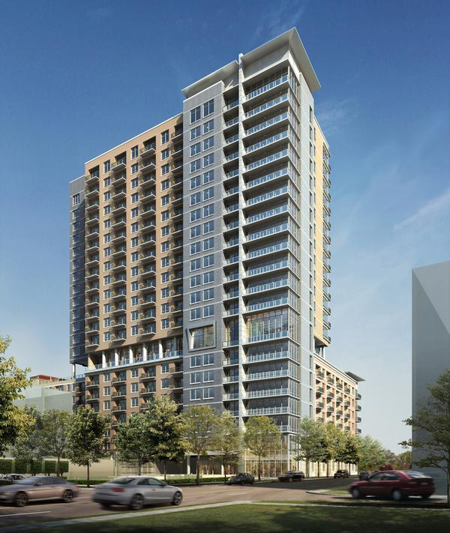
Staff Houston Business Journal
The Sovereign is the first phase of the mixed-use, walkable community called Regent Square, which is located on 24 acres off Allen Parkway adjacent to downtown. The 290-unit, 21-story apartment complex has an eighth floor amenity deck with a pool, Jacuzzi, outdoor fireplaces, cabanas, outdoor and indoor fitness centers, theater room and a resident vegetable and herb garden.
Considering the statistic that 84 percent of renters are pet owners, architects at Ziegler Cooper designed the outdoor space to be pet friendly, with a park on the roof and a pet spa where residents can get their loved ones groomed.
Residents also have a 24-hour security concierge service and valet parking.
The project is seeking LEED Silver certification.

